Aces of Comedy Series Adds Performance with
‘America’s Favorite Husband’ Steve Treviño at The Mirage Theatre
Thursday, Dec. 9

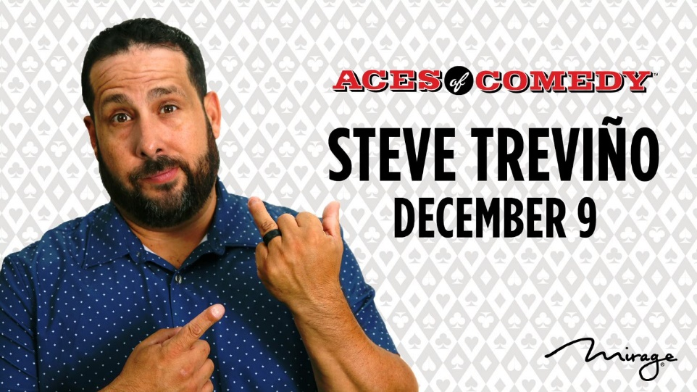
Tickets on Sale Thursday, Sept. 9 at 10 a.m. PT

LAS VEGAS (September 8, 2021) – The Mirage Hotel & Casino announced today it has added stand-up comedian Steve Treviño to its popular Aces of Comedy lineup. Dubbed ‘America’s Favorite Husband’ after releasing his comedy special “My Life in Quarantine,” Treviño will charm guests with his comedy at The Mirage Theatre Thursday, Dec. 9. The show is scheduled to begin at 10 p.m.
Tickets, starting at $29.99 (not including taxes and applicable fees), go on sale Thursday, Sept. 9 at 10 a.m. PT. Tickets can be purchased online at mirage.com/aces or ticketmaster.com. Guests looking for exclusive ticket prices and discounts for select Aces of Comedy comedians can sign-up for MGM Resorts International’s loyalty program, M life Rewards. To join, or for more information, visit mgmresorts.com/mlife.
Known for his tongue-in-cheek humor, Steve Treviño won the hearts of many fans by sharing his relatable pandemic experience as a husband, family man and nonessential worker, while finding humor and laughs through it all. Treviño won the hearts of many fans by sharing his relatable pandemic experience as a husband, family man and nonessential worker, while finding humor and laughs through it all. Since the comedy special’s premiere, Treviño’s videos and acts have received more than 175 million online views worldwide.

A true family affair, Treviño and his family share their story with the world in genuine, raw and real comedy specials including “‘Til Death,” “Sports, Marriage & Comedy with Steve Treviño” and “Steve Treviño & Captain Evil: The Podcast,” a podcast with his wife. Additionally, Treviño continues to break barriers in the comedy world and is committed to using his fame to help people in need. He is passionate about raising money through his events and performances for Helicopters For Heroes, an organization benefitting veterans.

Visit the MGM Resorts Entertainment Convene with Confidence page for additional information on the company’s plan to protect the health and safety of its employees and guests.

For high-res images, visit The Mirage Online Newsroom.

About Aces of Comedy
The Aces of Comedy series at The Mirage Hotel & Casino features one of the country’s most comprehensive and diverse comedic lineups. Over the last decade, the 1,257-seat Theatre at The Mirage has been the place to enjoy the best comedy in Las Vegas, featuring some of the most popular comedians worldwide including Tim Allen, Tiffany Haddish, Gabriel Iglesias, Jay Leno, Kathleen Madigan, Bill Maher, Ray Romano, David Spade, Iliza Shlesinger, Daniel Tosh and Ron White, among others.
About The Mirage
Ideally located on the Las Vegas Strip, The Mirage Hotel & Casino is the place to stay and play. From its iconic Volcano to the lush tropical pool, guests experience an exotic world-class destination unlike any other. The resort features contemporary accommodations; dynamic entertainment including The Beatles LOVE by Cirque du Soleil, Boyz II Men, Shin Lim: LIMITLESS and the Aces of Comedy series; tantalizing restaurants created by the world’s most renowned chefs including Tom Colicchio; a luxurious spa and salon; and Siegfried & Roy’s Secret Garden and Dolphin Habitat. The Mirage is operated by MGM Resorts International (NYSE: MGM). For more information and reservations, visit mirage.com, call toll free at (800) 374-9000, or find us on Instagram, Facebook and Twitter.

# # #

Media Contacts:

Katharine Sherrer / Allyson Wadman
MGM Resorts International Public Relations
ksherrer@mgmresorts.com / awadman@mgmresorts.com

For Steve Treviño:
Kelly MacGaunn
kelleemack pr, inc.
kelly@kelleemackpr.com

